COMPUTER SCIENCE FUNDAMENTALS AND CAREER PATHWAYS

Assignment 1- Foundation of Computer Science & Computational thinking

Assignment title- Design and stimulate a real-world process using flowcharts and pseudocode

Name: RAKSHIT PAL
Roll-no: 2501630004
Course: B.Tech CSE(Robotics and AI)

Course Code: ETCCCP105

Problem Selected

Product delivery in minutes(like Zepto/Blinkit/JioMart)

Introduction:

Product delivery in minutes such as Zepto, Blinkit, JioMarthave become an integral part of our life offering convenient and reliable product delivery at doorstep. These systems are not only user-friendly but also rely heavily on computational processes such as product management, payment verification, delivery partner allocation, and real-time tracking.

This assignment focuses on designing and simulating the working of Product delivery in minutes service using computational thinking principles. By applying abstraction, decomposition, and pattern recognition, the problem is analysed and structured into manageable components. A flowchart and pseudocode are then developed to represent the complete process logically. Finally, a sample implementation in Python demonstrates how a part of the system can be translated into working code.

The objective of this exercise is to bridge the gap between real-world problem-solving and computational design, while also improving algorithmic thinking and coding skills relevant to computer science.

Problem Analysis

Abstraction: 1. The costumerselect the products and makes the required online payment though the app.
2. The system checks the selection of product and processes the payment.
3. A driver is assigned for the product delivery their details are shared with the customer through the app.
4. The customer tracks the delivery partner in real-time through the app.

Decomposition: 1. User - Selects the required products and makes the required payment.
2. System - Checks the booking made and processes the payment.
3. Delivery partner Assigning - Match the booking with the nearest available delivery partner.
4. Delivery partner status - The driver’s real-time location and the estimated arrival time is made available to the costumer through the app.
5. Notify - The customer gets notified upon the arrival of delivery partner through the app.

Patter Recognition: 1. The user interface is similar to a food delivery service where instead of the food item(s) they choose location(s).
2. The payment process is also similar since its generally online, whether through UPI/cards or through cash on delivery.
3. The matching of drivers is similar to matching food delivery men (swiggy/zomato).
4. Status updates completely resemble the tracking system in food delivery apps.

Solution Design
- Flowchart
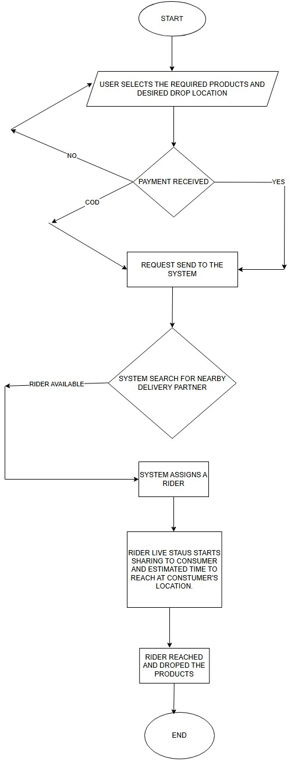

(B)Pseudocode
BEGIN
PRINT "Welcome to Service"
// Step 1: consumerinputs the delivery address.
INPUT consumer_location
INPUT destination
// Step 2: Total cart and time SET
cart = CALCULATE_CART(warehouse_location, consumer_address)
PRINT estimated_time SET estimated_time = CALCULATE_ETA(driver, user_location)
PRINT estimated_fare
// Step 3: Payment
INPUT payment_method
PROCESS_PAYMENT(payment_method, estimated_fare)
// Step 4: Search for available drivers nearby.
SET driver_list = FIND_DRIVERS_NEAR(user_location)
IF driver_list is EMPTY THEN PRINT "No delivery partner available. Please try again later."
EXIT
// Step 5: Match ride with the closest driver
SELECT driver = FIND_NEAREST_DRIVER(driver_list, consumer_address)
// Step 6: Notify driver
SEND_REQUEST_TO_DRIVER(driver, warehouse_location, consumer_address)
IF driver_accepts == FALSE THEN PRINT "Driver declined. Searching for another driver..." GO TO Step 5 ENDIF
// Step 7: Track ride
PRINT "Driver on the way..."
UPDATE driver_position
PRINT "Driver is ", distance_to_consumer, " km away" ENDWHILE
IF distance_to_user<= 40m
PRINT "Driver has arrived. Ride started."
// Step 8: End of ride
PRINT "Delivery Partner has reached your location."
PRINT "Thank you for using our Service!"
END

(C)Implementation
Input:
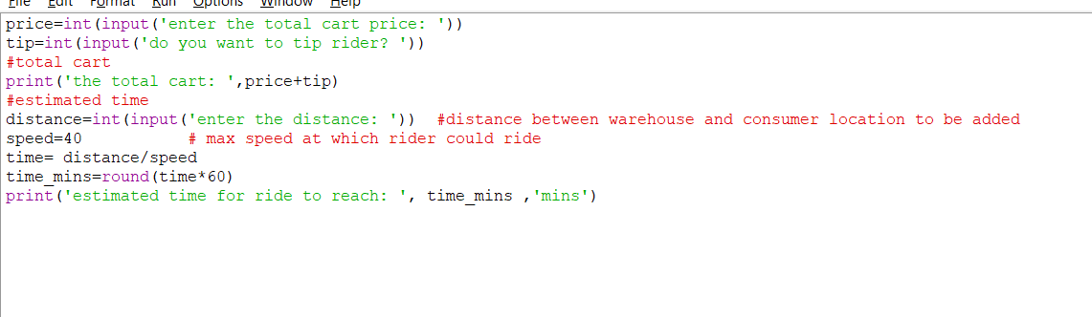

Output:
